Tab 1
Project setup
3 main decisions
- Training v.s. inference split on compute per hour
  - Pricing of tokens and when to run stuff (William based on power from Lance and power requirements), power requirements of training v.s inference (Lili/Srishti)
- Power from RT LMP v.s. tolling agreement (Houston, WEST can only use LMP)
  - Lance (Also EC Qs for pricing)
- Inclusion of BESS at either (physical or virtual toll)
  - When to use for data center vs when to sell to grid

Assigned Tasks and Deliverables:
The aforementioned prescribed task entails employing real options analysis to design an economically viable operating policy for allocation and timing for incurring training cost as well as power procurement during the next 6 months (starting 1 June 2026 to 1 December 2026) with corresponding profitability (i.e., volatility-dependent conditional payoff) estimates during this period.
- The report should provide a detailed description of the process of analysis, motivation/rationale justifying the methodology, and all assumptions.
- The report should value and estimate breakeven as well as marginal profitability increases for tolling fixed lease rate battery storage (BESS) at each location with recommendations as to under what market conditions (e.g., price and spread volatilities) either or both of these tolling arrangements would be economically viable.
- The analysis should substantively describe wind-solar intermittency in the context of MIHR citing the ERCOT data portal, and the contingency of the following prescribed unscheduled outage scenario(s) contingency contingencies, such as outages and other potential disruptions.

Training + Inference
Training v.s. Inference
Setup Brainstorming/Equations
Training
Power & computational requirements (based on parameter count and GPU FLOPS)
Parameters in notable artificial intelligence systems
Training computation vs. parameters in notable AI systems, by researcher affiliation
NVIDIA H100 Specs and Use Cases: When Hopper Acceleration Works for AI and HPC | HorizonIQ

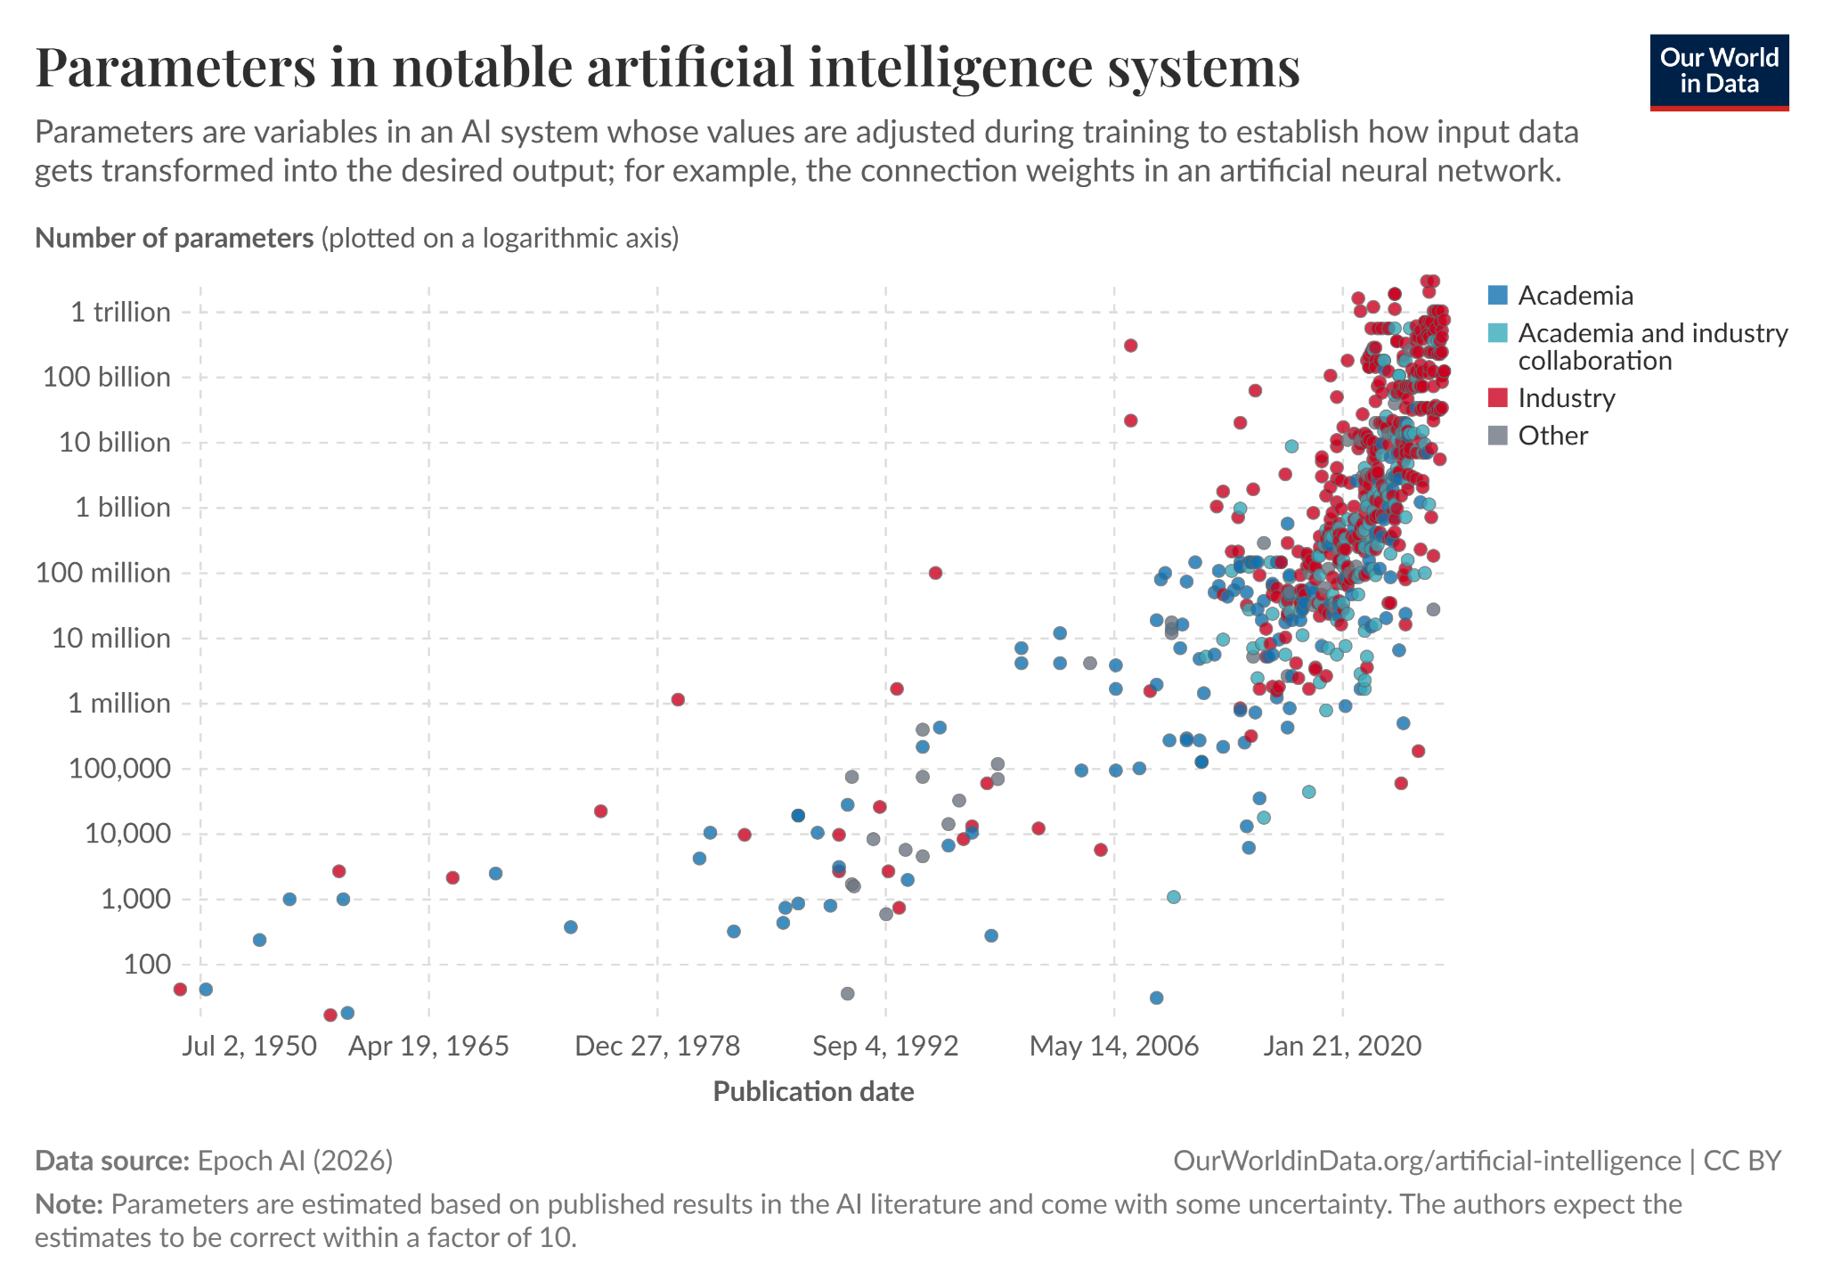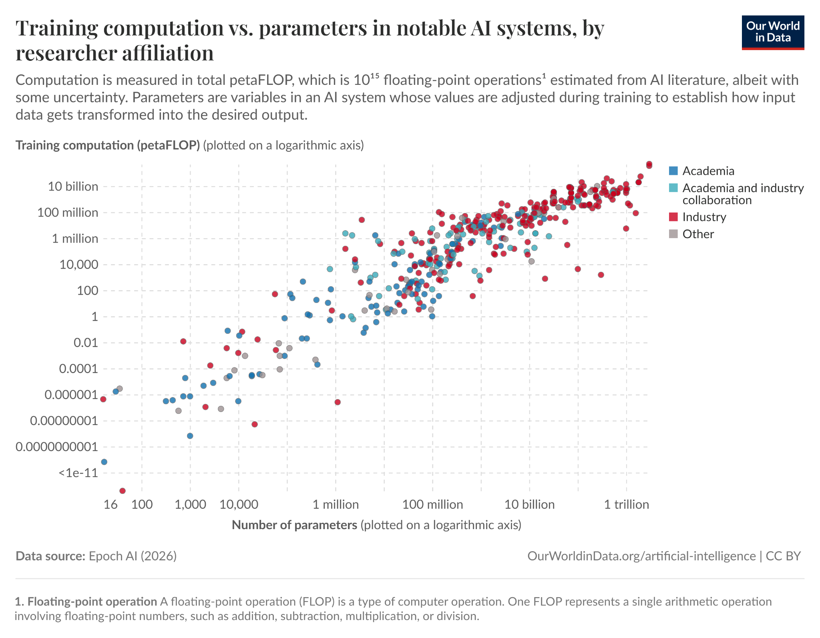
Based on the first graph, we see that the number of parameters within A.I. datasets have been increasing at an exponential rate, especially given the visually positive linear relationship on a logarithmic y-axis. We first restricted the dataset to post-2010 data. Therefore, extracting this relationship with a 0.202 R², we see that y = 2E-31e^{0.0021x} where x is the date in number format. As an example, we will assume that the industry standard of AI model releases is every 2 months (this will actually be variable in our model) after the first training time of 3 weeks. In other words, with regards to this project, our trainings will be on 6/01/2026 (model release on 6/22/2026), 6/22/2026 (model release on 8/22/2026), 8/22/2026 (model release on 10/22/2026), 10/22/2026 (model release on 12/22/2026, will not see revenue for this report). These dates will have a projected number of parameters of 258,564,055,666, 270,221,896,618, 307,152,221,682, 349,129,691,061, 379,273,539,685, respectively based on buildout until mid 2023. However, based on recent speed-up, if we want to be competitive with the most aggressive models (GPT 4o, Claude, Copilot, etc.), we need to increase this parameter count by a factor of 5-10x with reference to the latest models like DeepSeek Pro at 1.6T parameters, Xiaomi Mimo at 1.02T, ChatGPT-4 at 1.7T+, etc.. Therefore, we will use a 5x multiplier on our model to get 1,292,820,278,329, 1,351,109,483,088, 1,535,761,108,408, 1,745,648,455,305, and 1,898,617,498,423 parameters.
The second graph shows the relationship between the logarithmic scale of computation in petaFLOPS and the logarithmic scale of parameters. Based on our parameter counts, the initial model training will take an estimated 130,957,574,741 petaFLOPS of computation, followed by the subsequent trainings’ computational amounts of 141,269,312,142, 176,061,533,097, 219,422,484,389, and 253,501,521,201 petaFLOPS. These numbers are equal to 130,957,574,750,772 teraFLOPs for initial model setup, and 141,269,312,141,511, 176,061,533,097,437, 219,422,484,378,942, and 253,501,521,201,338 teraFLOPS for the subsequent training periods. This computation must be completed between the training start time and the “model release” dates.
Note that all of the numbers above for both parameters and FLOPS computational data depend on the training period (lower training period means more frequent model releases at lower computational power requirements, higher training period means less frequent model releases with more spread between computational power requirements), which will be a floating parameter in our dynamic programming model. For the sake of simplicity, we will assume that the training period for each model release will stay constant across the entire report lifecycle (it does not vary over time, but the model can vary the windows themselves).

Moving on to our hardware computational strength, from these numbers above, we need to consider the computational power of our datacenter hardware: we have 90000 H-100 class GPUs at each datacenter, measuring a total computational power capacity of 80MW for each 100MW datacenter. 180000 total H-100 class GPUs (160MW of computational capacity) gives us a large amount of teraFLOP computational strength (FP8 Tensor and BF16 Tensor for A.I. models ~several thousand teraFLOPS per GPU) - however, there are two types of H-100 GPUs with different computational specifications and we combine these to get an estimate on total GPU teraFLOP computational strength.

Srishti and Lili - we need to make a fair estimate on how many of the H100 GPUs are PCIe vs SXM in order to figure out the total theoretical computational strength. Then, we need to estimate the realistic sustained training throughput based on typical large transformer training (ChatGPT initially mentions several hundred to a thousand teraFLOPS per GPU in practice, much lower than theoretical maximum).

Then, we can assume that the petaFLOPS of computation for each training period will have to be accomplished by a varying split of H-100 PCIe vs SXM GPUs (SXM is better for training). In other words, using power data from Lance and a typical conversion rate from petaFLOPs/teraFLOPs to MWh or KWh of power usage, we can estimate the total MWh/KWh of training power usage for each training period and how/when to dedicate that power over the training period subject to a varying split of H-100 PCIe vs SXM GPUs, with distinct computational strength (note that training period will be adjustable in the model)

3 main decisions to model/forecast;
- How often do we want to release a new model (this will have to be informed by inference pricing & revenue forecast, we initially consider bimonthly releases after initial model training as not all gpus will be dedicated to training at any given moment post-release, but we can leave this as an open model parameter)
- What is the ideal split between SXM and PCIE H100 GPUs for the data-centers to maximize training potential & inference revenue v.s. power costs
- What is our training v.s. inference time/power split at any given moment in time based on total required computation for the models and power costs

As training period increases, we need less H-100s dedicated to training daily (above the minimum of 500 MWh total each day) → as it decreases, we need more H-100s workload dedicated → note that more training also means better models come up earlier, so more optionality and growth in revenue, but it means less present revenue
The hourly split between training and inference will be based on power costs to each process and projected revenues, which are informed by the training period. At the same time, the ideal training period is influenced by projected revenues from future models and the tradeoff with reduced current revenue (informed by hourly split between training and inference). As they both are influenced by projected revenue, it only makes sense to vary one of these parameters while holding the other constant (and recursively testing). The idea is that once we have a framework to estimate future revenue from models based on computational power dedicated to inference, we can use the following process:
- Vary training period values first, setting total amount of time available for H-100 training split to accomplish the required computation for the model releases (to vary training period, we use the same idea of estimating parameter count for future models based on training start date and computational FLOP requirements based on parameter count).
- Based on a set training period, we have the total computational FLOPS expected for the models, which we can convert to total training MWh based on the conversion formula for H-100 SXM or PCIe specification. Our inference section will have a prediction model for revenues based on model releases and token usage. We use these to calculate the ideal varying hourly split for training/inference based on power costs to maximize profit and subject to minimum daily MWh training
Inference
Basic constraints
- Can only use power/GPU compute not currently being used for training
- Need token revenue to at least cover marginal cost from project requirements (inference request rate distribution minimum is such that the revenues cover marginal cost)
Revenue
- Current model revenue is based on total token usage & request distribution
  - We can model out cost per MM token from other frontier AI models
  - Estimate/provide a reasonable tokens per request based on inference data from other LLM models
  - Request rate will be based on hardware (what H-100s are available at any given moment w/ their combined computational strength/power from the power/computation section below)
    - Maximum request rate is such that power/computational cost does not exceed that unused for training for any given hour
- Future model releases from training will have revenue calculated the same way, but with modified assumptions regarding
  - 1) future token cost; from preliminary research, token costs (for the consumer) seem to be halving every couple of months (revenue per token dropping)
  - 2) projected tokens per request
  - 3) request rate
- Power/computation: William
  - Revenue
1) Token cost per model (forecasted per AI model release)
2) # of tokens per request (forecasted per AI model release)
- Requests per hour, determined by:
  - Number of tokens per MWh (based on inference compute conversion provided in project) → convert to requests per MWh using 2)
    - Total inference MWh per hour (from conversion input)
    - A + b = requests per hour
    - Requests per hour from c) combined with 2) and 1) gives revenue per hour
Conversion: Convert compute decision variables into usable MWh for power cost calculations where F terms are all total teraFLOP hourly and s terms are effective sustained teraFLOP/s for PCIE/SXM under training/inference workloads.
$E^\{facility\}_\{i,t\}=0.0011111\backslash left(\backslash frac\{F^\{train,SXM\}_\{i,t\}\}\{3600 \backslash cdot s^\{train,SXM\}_\{H100\}\}+\backslash frac\{F^\{train,PCIe\}_\{i,t\}\}\{3600 \backslash cdot s^\{train,PCIe\}_\{H100\}\}+\backslash frac\{F^\{infer,SXM\}_\{i,t\}\}\{3600 \backslash cdot s^\{infer,SXM\}_\{H100\}\}+\backslash frac\{F^\{infer,PCIe\}_\{i,t\}\}\{3600 \backslash cdot s^\{infer,PCIe\}_\{H100\}\}\backslash right)$
→ this can be less than or equal to 200 every hour, ≤ 100 for each data center
$E^\{train\}_\{i,t\}=F^\{train,TFLOP\}_\{i,t\}\backslash cdot\backslash frac\{0.0008889 \}\{3600\backslash cdot s^\{train,TFLOP/s\}_\{H100\}\}$
$E^\{compute,train\}_\{i,t\}=0.0008889\backslash left(\backslash frac\{F^\{train,SXM\}_\{i,t\}\}\{3600 \backslash cdot s^\{train,SXM\}_\{H100\}\}+\backslash frac\{F^\{train,PCIe\}_\{i,t\}\}\{3600 \backslash cdot s^\{train,PCIe\}_\{H100\}\}\backslash right)$
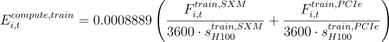
$E^\{compute,infer\}_\{i,t\}=0.0008889\backslash left(\backslash frac\{F^\{infer,SXM\}_\{i,t\}\}\{3600 \backslash cdot s^\{infer,SXM\}_\{H100\}\}+\backslash frac\{F^\{infer,PCIe\}_\{i,t\}\}\{3600 \backslash cdot s^\{infer,PCIe\}_\{H100\}\}\backslash right)$
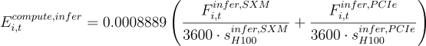
$E^\{compute\}_\{i,t\}=0.0008889\backslash left(\backslash frac\{F^\{train,SXM\}_\{i,t\}\}\{3600 \backslash cdot s^\{train,SXM\}_\{H100\}\}+\backslash frac\{F^\{train,PCIe\}_\{i,t\}\}\{3600 \backslash cdot s^\{train,PCIe\}_\{H100\}\}+\backslash frac\{F^\{infer,SXM\}_\{i,t\}\}\{3600 \backslash cdot s^\{infer,SXM\}_\{H100\}\}+\backslash frac\{F^\{infer,PCIe\}_\{i,t\}\}\{3600 \backslash cdot s^\{infer,PCIe\}_\{H100\}\}\backslash right)$
→ model constraint is this must be less than or equal to 160 every hour aggregate across data centers, ≤ 80 for each data center

Lance -- Power from RT LMP v.s. tolling agreement

Model Dynamic
Basic model dynamic
For training/inference split, the model’s decision variables for either data center are going to be:
Hourly
- SXM compute assigned to training
- PCIE compute assigned to training
- Remaining SXM + PCIE compute assigned to inference
  - Can assign up to the full remaining capacity of FLOP compute, but can assign less if power is too expensive)

Model-variable parameters
- Training period (model release schedule)

Objective: Maximize total inference revenue - total power cost

Inputs:
Conversion: Convert compute decision variables into usable MWh for power cost calculations where F terms are all total teraFLOP hourly and s terms are the effective sustained teraFLOP/s for PCIE/SXM under training/inference workloads.
$E^\{facility\}_\{i,t\}=0.0011111\backslash left(\backslash frac\{F^\{train,SXM\}_\{i,t\}\}\{3600 \backslash cdot s^\{train,SXM\}_\{H100\}\}+\backslash frac\{F^\{train,PCIe\}_\{i,t\}\}\{3600 \backslash cdot s^\{train,PCIe\}_\{H100\}\}+\backslash frac\{F^\{infer,SXM\}_\{i,t\}\}\{3600 \backslash cdot s^\{infer,SXM\}_\{H100\}\}+\backslash frac\{F^\{infer,PCIe\}_\{i,t\}\}\{3600 \backslash cdot s^\{infer,PCIe\}_\{H100\}\}\backslash right)$
→ this can be less than or equal to 200 every hour, ≤ 100 for each data center
$E^\{train\}_\{i,t\}=F^\{train,TFLOP\}_\{i,t\}\backslash cdot\backslash frac\{0.0008889 \}\{3600\backslash cdot s^\{train,TFLOP/s\}_\{H100\}\}$
$E^\{compute,train\}_\{i,t\}=0.0008889\backslash left(\backslash frac\{F^\{train,SXM\}_\{i,t\}\}\{3600 \backslash cdot s^\{train,SXM\}_\{H100\}\}+\backslash frac\{F^\{train,PCIe\}_\{i,t\}\}\{3600 \backslash cdot s^\{train,PCIe\}_\{H100\}\}\backslash right)$

$E^\{compute,infer\}_\{i,t\}=0.0008889\backslash left(\backslash frac\{F^\{infer,SXM\}_\{i,t\}\}\{3600 \backslash cdot s^\{infer,SXM\}_\{H100\}\}+\backslash frac\{F^\{infer,PCIe\}_\{i,t\}\}\{3600 \backslash cdot s^\{infer,PCIe\}_\{H100\}\}\backslash right)$

$E^\{compute\}_\{i,t\}=0.0008889\backslash left(\backslash frac\{F^\{train,SXM\}_\{i,t\}\}\{3600 \backslash cdot s^\{train,SXM\}_\{H100\}\}+\backslash frac\{F^\{train,PCIe\}_\{i,t\}\}\{3600 \backslash cdot s^\{train,PCIe\}_\{H100\}\}+\backslash frac\{F^\{infer,SXM\}_\{i,t\}\}\{3600 \backslash cdot s^\{infer,SXM\}_\{H100\}\}+\backslash frac\{F^\{infer,PCIe\}_\{i,t\}\}\{3600 \backslash cdot s^\{infer,PCIe\}_\{H100\}\}\backslash right)$
→ model constraint is this must be less than or equal to 160 every hour aggregate across data centers, ≤ 80 for each data center
Power (will run multiple models to determine highest profit scenario, basically whether to exercise 2 and 3):
- Hourly RT LMP power price estimates
- Tolling price
- Battery tolling power price
- Up to 200 MWh of facility power drawn per hour
Compute requirements/abilities
- Minimum training requirement of 500 MWh training compute daily (on a H-100 PCIE/SXM this is about 1.8 * 10²³ or 2.6 * 10²⁴ FLOPs daily)
- Chosen H-100 hardware giving us computational ability for our datacenters (teraFLOP capacity for both SXM/PCIe specs)
  - Cap = total computational teraFLOP ability over an hour of workload
  - Estimated sustained teraFLOP ability per SXM/PCIe compute for training/inference workloads
- Compute-clearing demand >= supply (inference compute + training compute = total compute), which necessitates demand for inference > supply for inference = (total supply of compute/power - supply for training)
- Equations for total parameters based on model training start date (given by schedule) and FLOP compute required for each training period based on parameters
  - Fixed first model release date based on 100% compute dedicated to training & training parameter count starting on 6/1/2026
Revenue
- Token cost per model (forecasted per AI model release)
- # of tokens per request (forecasted per AI model release)
- Requests per hour, determined by:
  - Number of tokens per MWh (based on inference compute conversion provided) → convert to requests per MWh using 2)
  - Total inference MWh per hour (from conversion input)
  - A * b = requests per hour
  - Requests per hour from c) combined with 2) and 1) gives revenue per hour

